**quiz for forces and electromagnets**

1. If I had a knife and needed to cut something which one is better and explain why?(2 marks)

* Blunt knife
* Sharp knife

1. On a truck does a deflector reduced fuel consumption or increase speed?( 1 mark )
2. Draw a streamline shape (1 marks)
3. Tick the boxes that are correct what helps car grip on ice?(2marks )

Spikes on wheels nothing

Chains on wheels dry wheels

1. 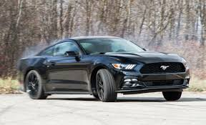If I had a car what are the forces surrounding it be ? ( 4 marks )

A

B

c

C

What is force a? (1mark)

what is force B? (1 mark)

what is force c?(1 Mark)

what is force D?(1 mark)

6)how could you make this faster draw on your examples? (2 marks)

1. If I were to put a slate on a muddy surface and didn’t want it to sink what would I do? ( 2 marks)
2. Name an aerodynamic shape? ( 2 marks)